Seed

Product Documentation

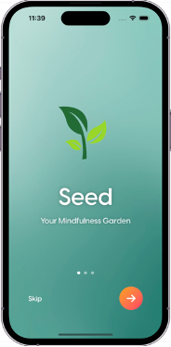

Wei-en Chi

Yi-tzu Liu

Sol Merritt

Pragnya Patil

Nigel Whiteoak

With thanks to Jack Lau for his contributions

# Table of Contents

Table of Contents 2

Installation Guide 2

Introduction 3

System Requirements 3

Hardware Requirements 3

Software dependencies 3

Software Installation 3

User Guide 9

Introduction 10

Opening the app 10

Using the app for the first time 10

Undertaking a mindfulness activity 10

Undertaking a journalling activity 11

Adding a seed to your garden 12

Keeping track of your progress 13

Troubleshooting 13

FAQs 13

Glossary 14

Maintenance Guide 14

Maintenance Guide for Seed App Frontend 15

Overview 15

Maintenance Practices 15

EXAMPLE Maintenance Guide for Seed App Backend 19

# Installation Guide

## Introduction

Welcome to Seed, the app to encourage daily mindful habits. Please install the app on your device to discover the benefits of daily mindfulness.

## System Requirements

Note that Seed has the following requirements:

* iOS 18
* macOS 14 Sonoma

### Hardware Requirements

Seed is designed to run on an Apple iPhone running iOS 18 or above. It is not yet available for Android devices or any other platform.

To install Seed, you will require a macOS device compatible with macOS 14 Sonoma.

### Software dependencies

Seed installation requires XCode, for which the latest version can be found here:

[XCode Version 16.1 (16B40).](https://apps.apple.com/gb/app/xcode/id497799835?mt=12)

## Software Installation

Ensure your devices meet the system requirements and software requirements.

From the GitHub repository, clone the project by selecting ‘Code” and ‘Open with Xcode’.

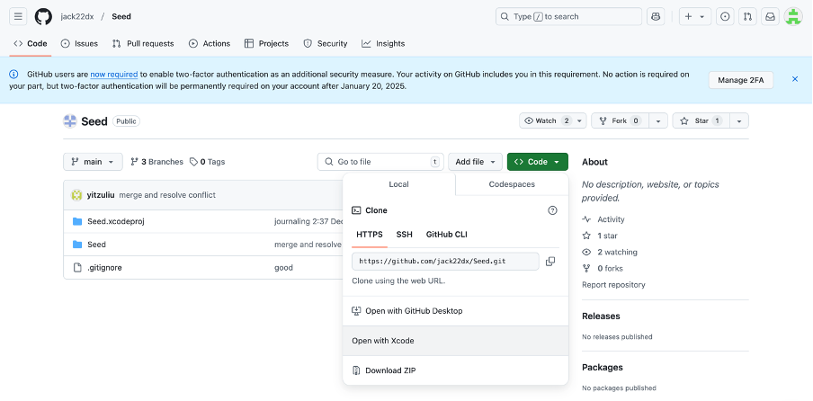

Clone the **main** branch:

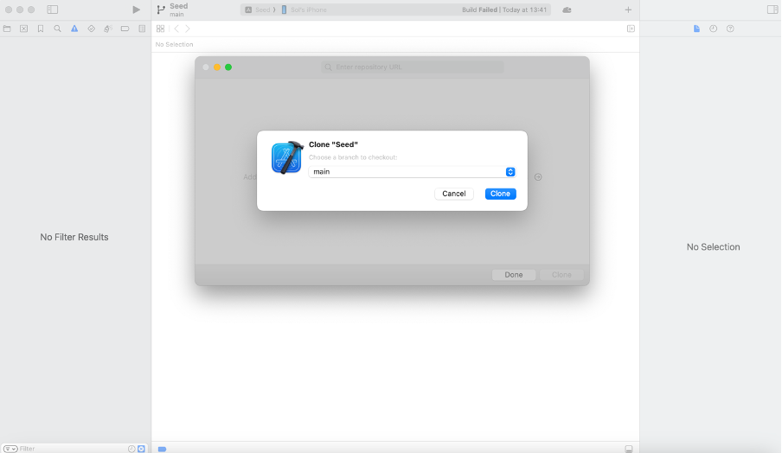

Trust and open:

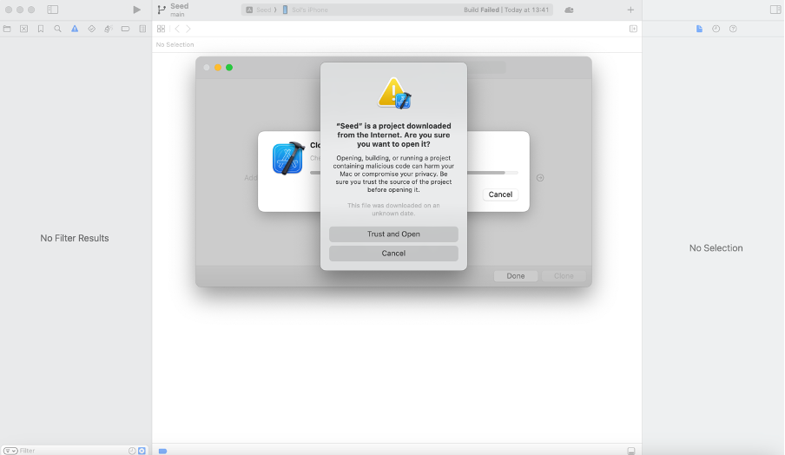

Ensure you have signing capabilities, if not already registered, ensure your email is connected to the [Apple developer program](https://developer.apple.com/programs/enroll/) but there is no requirement to be enrolled, edit the bundle identifier to be unique to your name:

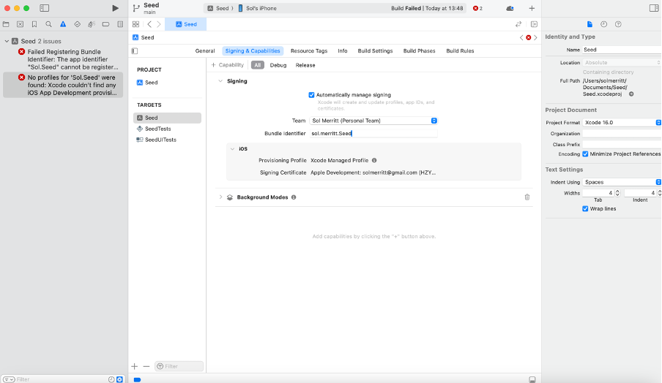

Connect your iOS device via cable or over your local network:

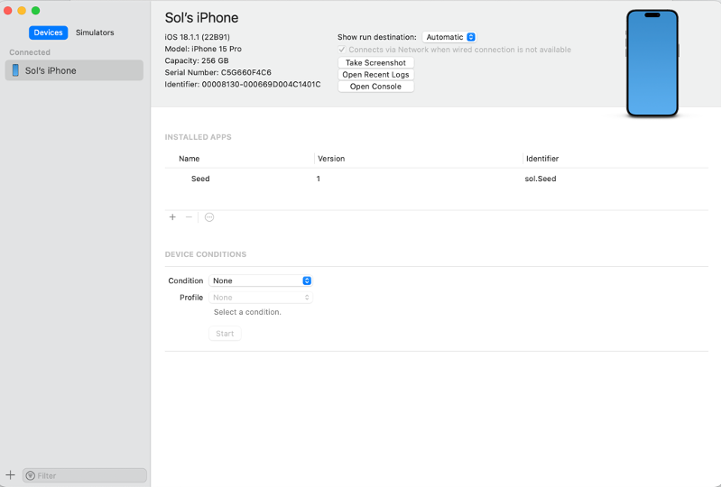

Ensure you iOS device has developer mode enabled, in Settings > Privacy and Security > Developer Mode.

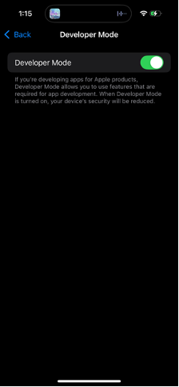

Select your device from the top bar:

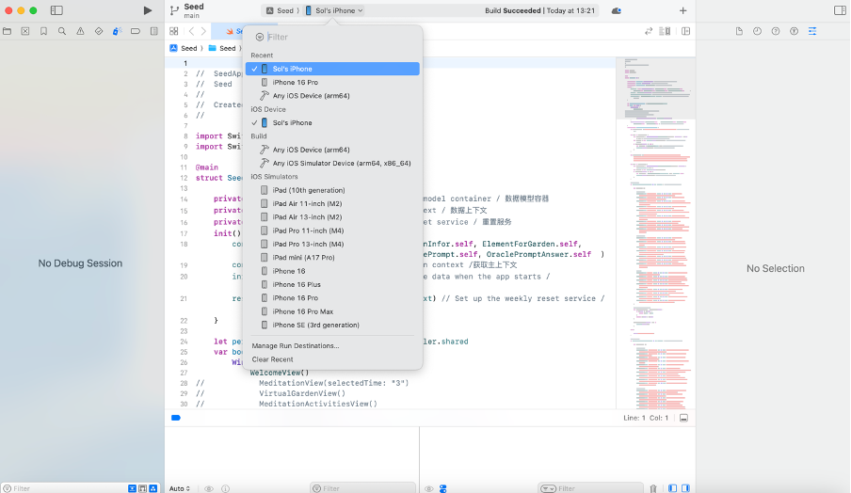

Select Product > Build then Product > Run to add the app to your device:

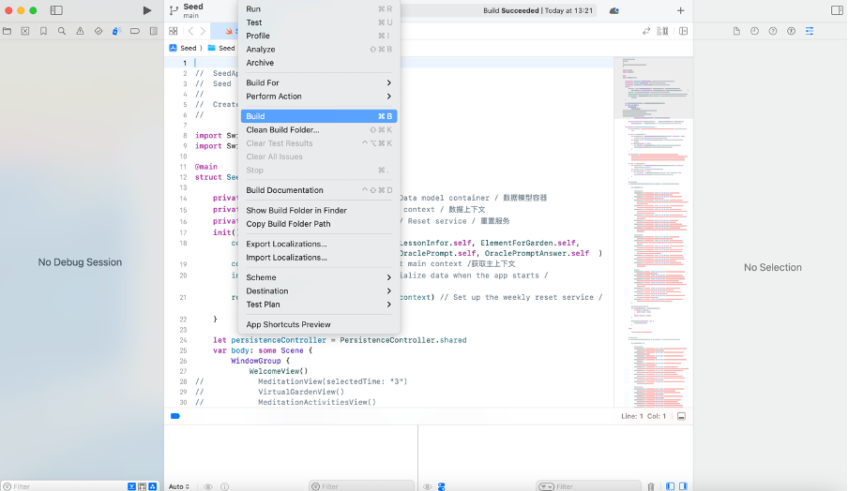

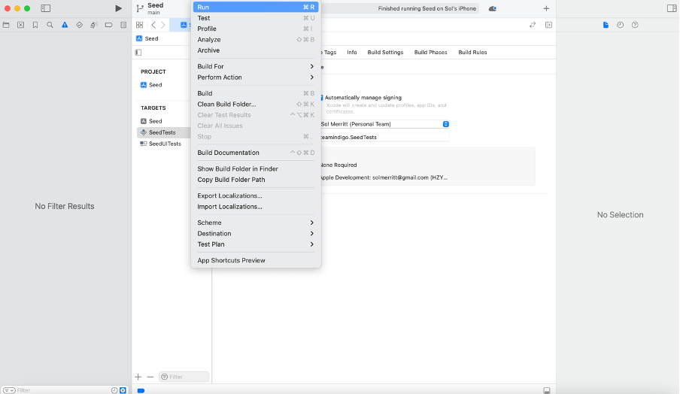

Ensure you trust the app on your iPhone: Settings > General > VPN and Device Management:

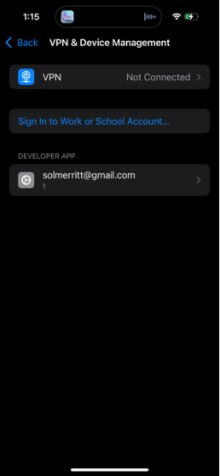

The seed app should now be installed and ready to open, for information on how to use the Seed app, please reference the User Guide.

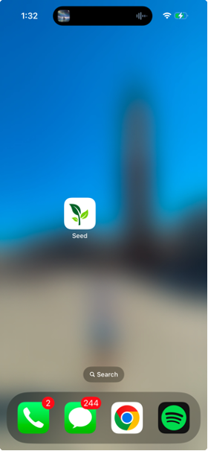

# User Guide

## Introduction

Welcome to Seed – now that you have installed the app you are ready to begin your mindfulness journey.

## Opening the app

To open, simply tap the app icon on your phone’s home screen.

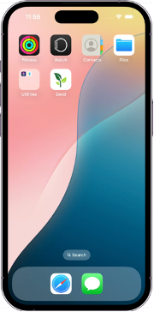

## Using the app for the first time

The first time that you open the app you will be introduced to the layout, pathways, and prompted to enter your name.

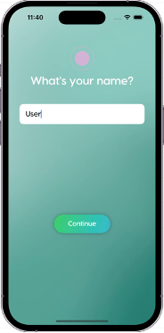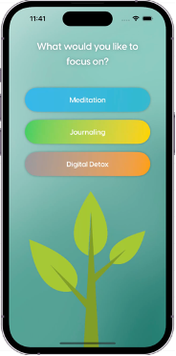

## Undertaking a mindfulness activity

To undertake a mindfulness activity, on the activities page select the meditation pathway, from here you can select from a list of activities including guided meditations, breathing exercises, and body scans. Select your activity and press start, follow along with the audio (you can pause at any time) and upon completion you will receive your seed.

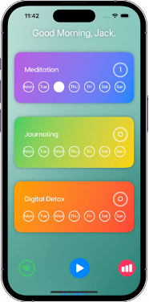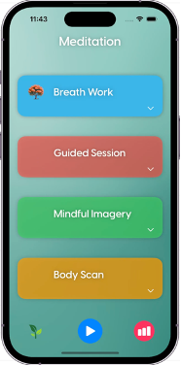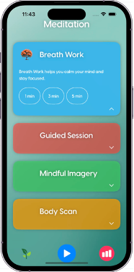

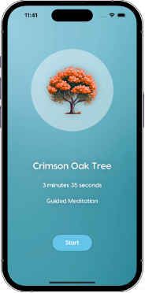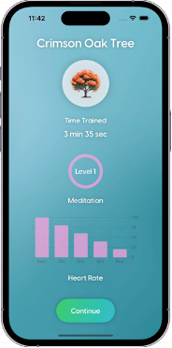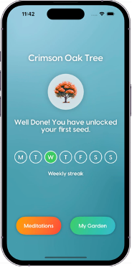

## Undertaking a journalling activity

To undertake a journaling activity, select the journaling pathway from the activities page, journaling consists of different prompts for you to respond to daily. You can review your previous prompts from the progress page. Like meditation activities, journaling earns you seeds which can be viewed in your seed bank and added to your gardening.

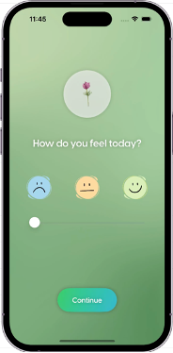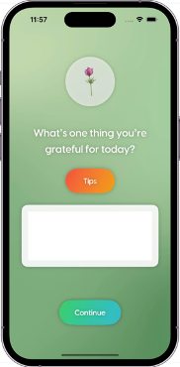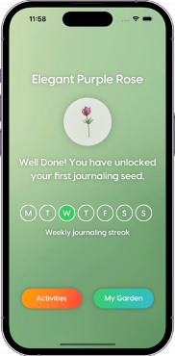

Undertaking a digital detox activity

To undertake a digital detox activity, select the digital detox pathway from the activities page. When you press start a timer will appear, this times your detox period, once you have finished press end. Your previous detoxes can be reviewed from the progress page.

|  |  |  |  |  |
| --- | --- | --- | --- | --- |
|  |  |  |  |  |
| Activities Page | After selecting digital detox | During digital detox | End of detox period | Final detox screen |

## Adding a seed to your garden

Once you have undertaken an activity you will be rewarded with a seed which you may add to your garden. To add a seed to your garden, head to the garden page, click on the plus icon in the top left of the screen. From your seed bank select the seed you wish to add to your garden. You can drag your seed into whichever position you desire.

|  |  |
| --- | --- |
| Garden Page |  |
| Garden Page | Seed Bank |

## Keeping track of your progress

To review your progress, navigate to the progress page, from here you can see your levels for the three mindfulness pathways, your daily streaks, and review completed activities.

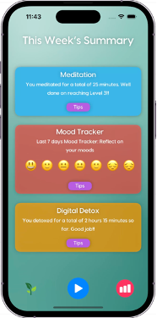

## FAQs

Can I pause my meditation or digital detox?

Yes, you can! Seed lets you pause your meditation or digital detox session if you really need to, although, we recommend completing the activity in one go.

Can I move the seeds I have placed in my garden?

Yes, simply hold and drag your seeds to move them around your garden.

How can I review my journal entries?

To review all your previous journal entries, navigate to the progress page and tap on the journaling box.

## Glossary

Confused about what a term means? Please check below.

**Seed** - your seeds are rewards for completing your mindfulness activities: a variety of natural objects that you can use to populate your virtual garden.

**Journalling –** this pathway helps you to record your thoughts and emotions, storing them so you can refer to them later.

**Digital Detox** – take some time out of your day to switch off from your digital devices and live in the real world!

**Mindfulness** - involves intentionally bringing one’s attention to the internal and external experiences occurring in the present moment.

**Meditation** – the intentional practice of focusing the mind on the present, both internal experiences and the external environment.

**Seed bank –** this is where your rewards are placed when you complete your mindfulness activities. From here you can select your seeds and use them to populate your virtual garden.

**Garden** – this is the place to position your seeds once you’ve earnt them

**Body scan** – a form of meditation that focuses on internal sensations.

**Pathway** – this refers to a group of activities of a similar type, e.g. journalling, digital detox

# Maintenance Guide

The following guide provides details for modifications and maintenance of code in our app ‘Seed’. It is a prerequisite to be able to code in Swift in order to understand and build upon the existing code.

## Folders

The app contains the following folder and views in each of the folders:

1. Main Views Folder: This folder contains ‘ContentView.swift’ file which is the first means of access for selecting Meditation, Journaling and Digital detox activities. Additionally, this folder contains all the views categorized as main such as the following:
   1. ‘WelcomeView’ introduces the user to the app. A gradient.mp4 is implemented for using PlayerUI and AVKit in Swift, text for welcoming the user to the app is coded for and a skip and an arrow button are provided to transition between pages.
   2. NameView allows the user to enter their name which will be stored and referenced through their time on the app.
   3. VirtualgardenView categorizes all the garden elements present as rewards for journaling, mediation and digital detox which is displayed when clicked on the plus button on the top left-hand side of the page. The functionality of the scorable garden, colors and size are coded here. From this view, it is possible to navigate to the ContentView and WeeklySummaryView page using the navigationbar in the code.
   4. WeeklySummaryView displays the aggregated time a user spent meditating and digital detoxing, and their corresponding levels achieved. It also provides a Journaling summary containing the user’s response to prompts from the journaling activities. Here the code receives an OraclePrompt and the use responses as OraclePromptAnswer from our database. This page also allows for navigation to our VirtualGardenView and ContentView.
2. Model Folder: This folder contains files such as ‘LessonInfor’, ‘User’, ‘User log’ ‘Oracle tip’ to manage interactions with SWIFT data and datastructures. This is used by other views such as Meditationstreak view, JournalingStreakView and DigitalDetoxStreakView to retrieve, save and show progress and tips to the user.
3. Meditation Views Folder: In this folder, the files for viewing meditation activities, introduction to meditation view, starting a meditation and accessing the summary and streaks of meditation activities performed are stored. All meditation related modifications must be made in this folder.
4. Journaling Views: Journaling questions are stored here to be displayed incrementally according to the level of the user. The level of the user increasing in count which is coded for in the JournalingStreakView present here. All Journaling prompts and user level acquired after achieving a journaling activity modification must be made in this folder.
5. Digital Detox Views: This folder contains Digital detox views to start, stop and play a digital detox timer that is linked to the content view page from the Main Views folder. All Digital detox related modifications must be made in this folder.
6. Assets: All the images related to the app are compiled here in a .png format. Several views such as VirtualGardenView, JournalingView call these assets to be used in the code. All new additions to images must be added here.
7. Meditation Audios Folder: Stores guided meditation audios to be used in MeditationStartView under the Mediation Views folder where audios can be updated as required.
8. Oracle is stored and initialized using Swift data in the SeedApp.Swift file so it can function as a shared resource among the journaling, mediation and digital detox views. The oracle contains OracleTip, OraclePrompt and OracleFact models which are populated from a rational document based on user stories. Additional facts, tips and prompts can be easily edited by using Model and the struct OraclePrompt/Tip/Fact which would be reflected accordingly in mediation, journaling and digital detox view.